Quick Start Guide: SparseGridCollocation

Contents

Initial Installation and Setup 2

The Pull Action 5

Microsoft Account Signup 6

Author: Nick Wilton

Version: 1.0

# Initial Installation and Setup

How to get up and running with the SparseGridCollocation C++ solution using Visual Studio 2017

1. Get or Modify Visual Studio 2017 Community Edition
2. Either download visual studio community edition from the menu at:

<https://www.visualstudio.com/>

or the direct link:

<https://www.visualstudio.com/thank-you-downloading-visual-studio/?sku=Community&rel=15>

Run the installer selecting basic options until you see the screen in step 2

1. If you already have this edition installed select Control Panel\Programs\Programs and Features and then right-click and ‘Change’ on the Visual Studio item as below:

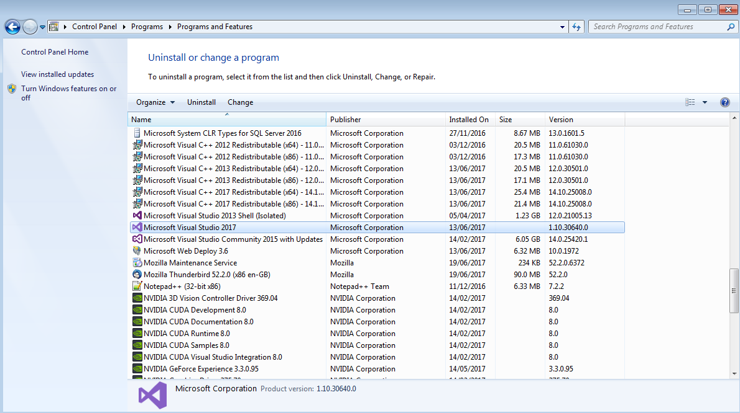

Then select the Modify option:

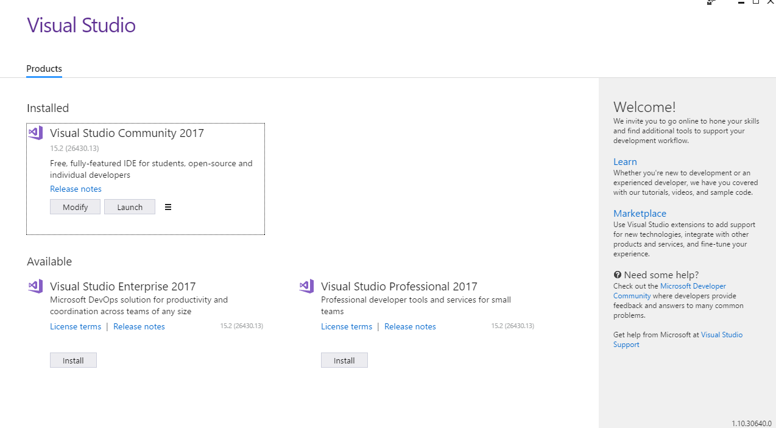

1. Whether you have downloaded and installed a new version, or are modifying an existing installation of Visual Studio you will be presented with the following screen.

Select Desktop development with C++ and then Modify.

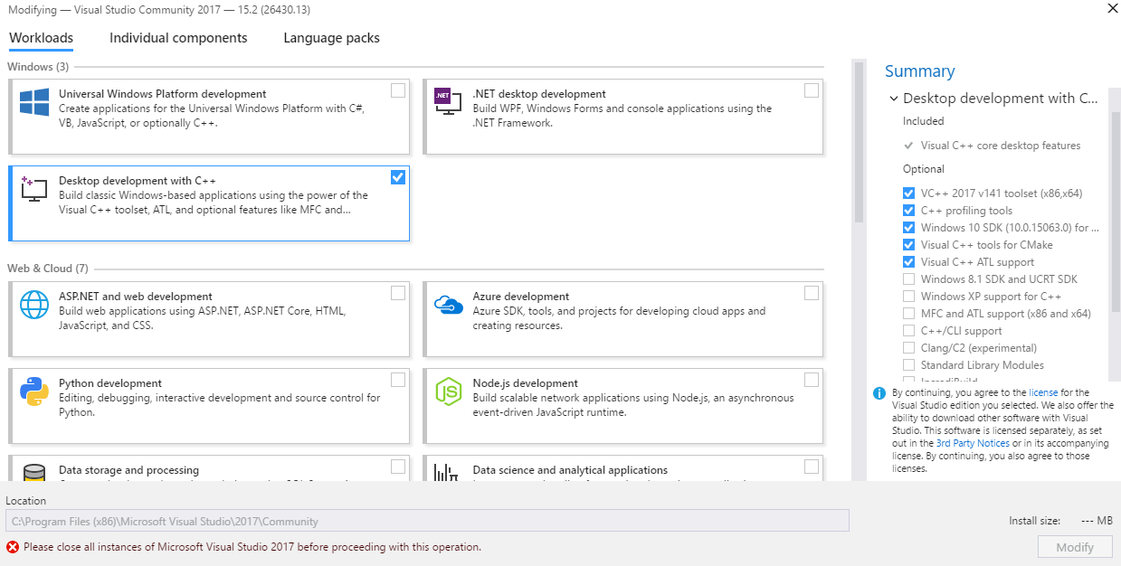

1. The installation process may take a while, but once it is complete, open Visual Studio and you should see a screen similar to, otherwise if you are asked to sign up or sign in follow the relevant section of this document before returning here.

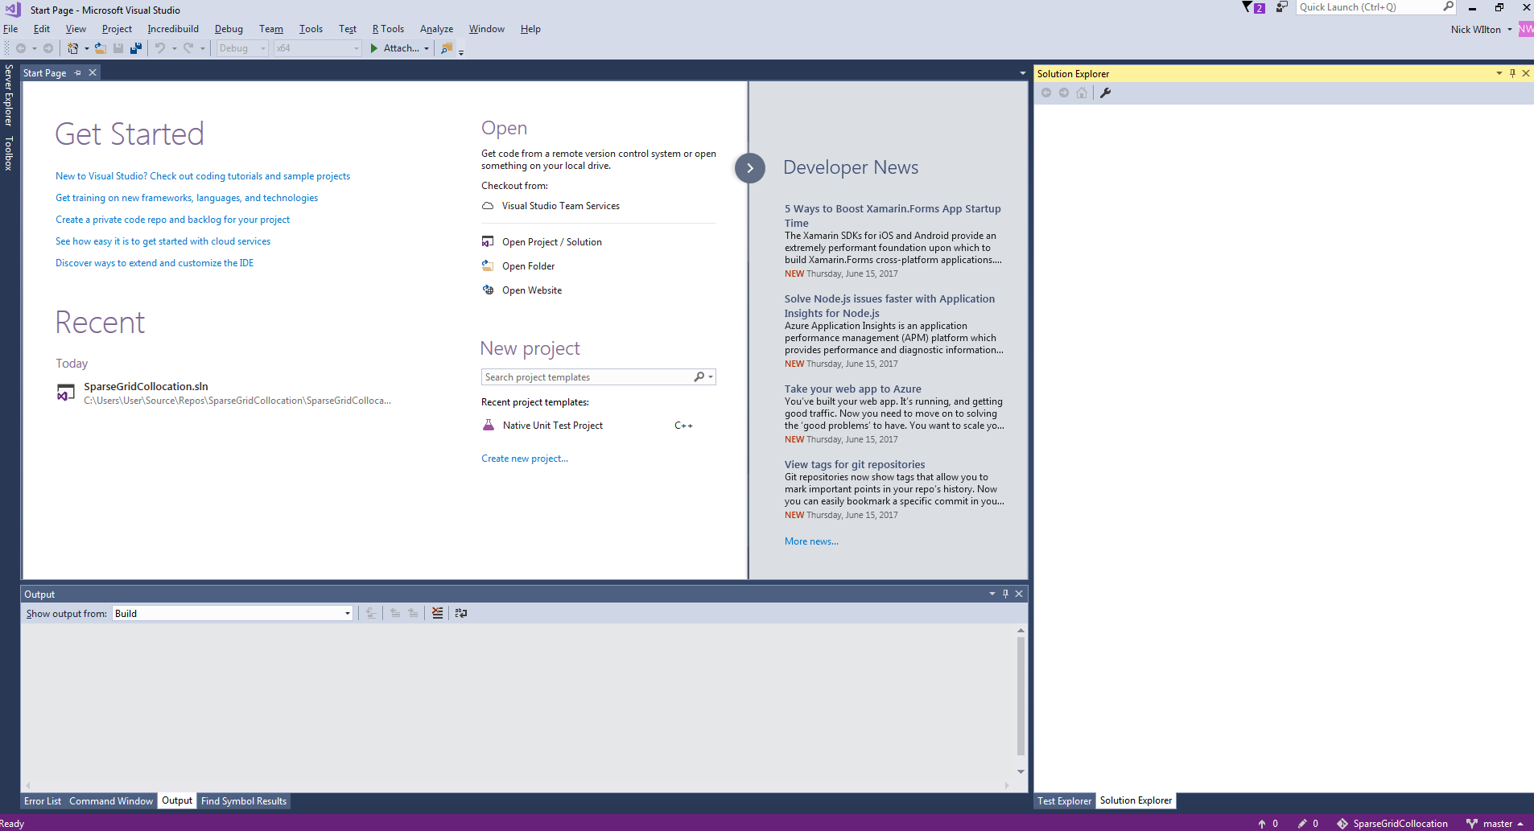

1. Select View>Team Explorer and in the new window ‘manage connections’ icon, as highlighted below:



1. Select New Local Git Repository in a location on your local filesystem.

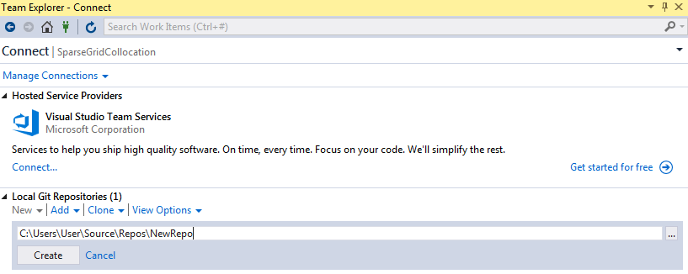

1. Select the ‘Clone’ dropdown menu and carefully enter the URL to the central Git repository, currently located at:

<https://github.com/NicholasWilton/SparseGridCollocation>

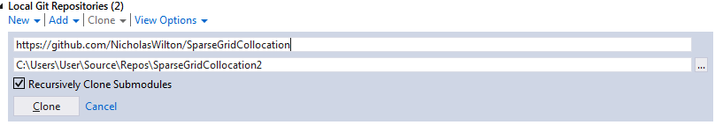

This action will copy the master codebase down from the server to your local machine

allowing you to make changes, compile or run the code yourself.

1. Double click on the SparseGridCollocation entry to open the local repository and showing the project screen below:

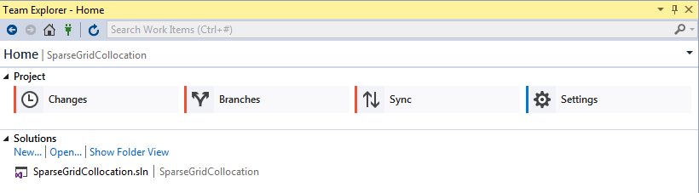

1. Either double click on SparseGridCollocation.sln in the above screenshot or select ‘Open’ and browse one folder down to open the codebase from the same file.
2. Open Solution Explorer from the View menu drop down to see something similar to the structure below:

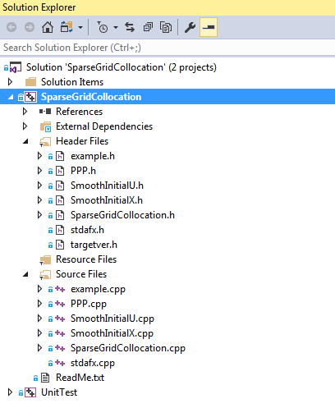

The solution should now be ready to be edited, compiled or run in the usual fashion.

# The Pull Action

How to pull the latest version of the codebase to your machine if you have an older version.

1. Select Team Explorer and then the Sync action:

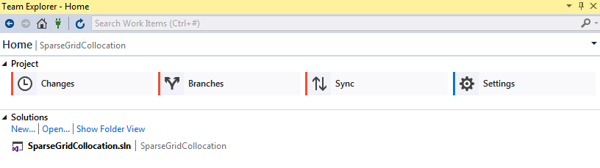

1. Select Pull, under the incoming commits sub-heading:

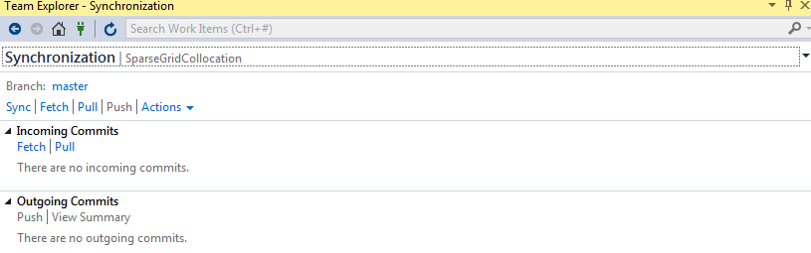

1. So long as you have not made conflicting changes to your local copy, the new changes should be automatically merged into your local repository. If you receive a message asking you to manually resolve conflicts either seek advice on line or contact the author of this document.

# Microsoft Account Signup

On program start up, you will likely be prompted to create a new Microsoft account to use visual studio for longer than the evaluation period, other than this requirement the community edition is generally free to use

1. To create a new account, select ‘sign up’ from the options below:

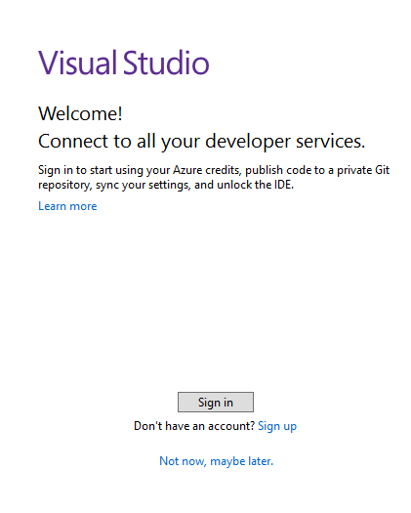

1. Enter an email address and a new password:

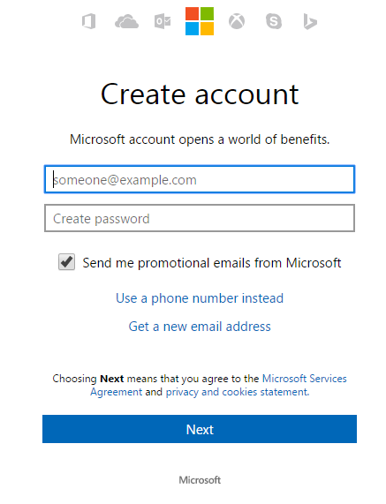

1. Follow any email verification requirements and Visual Studio should run as per usual.